WorkHorse Printer - Z-Axis Motor Mount
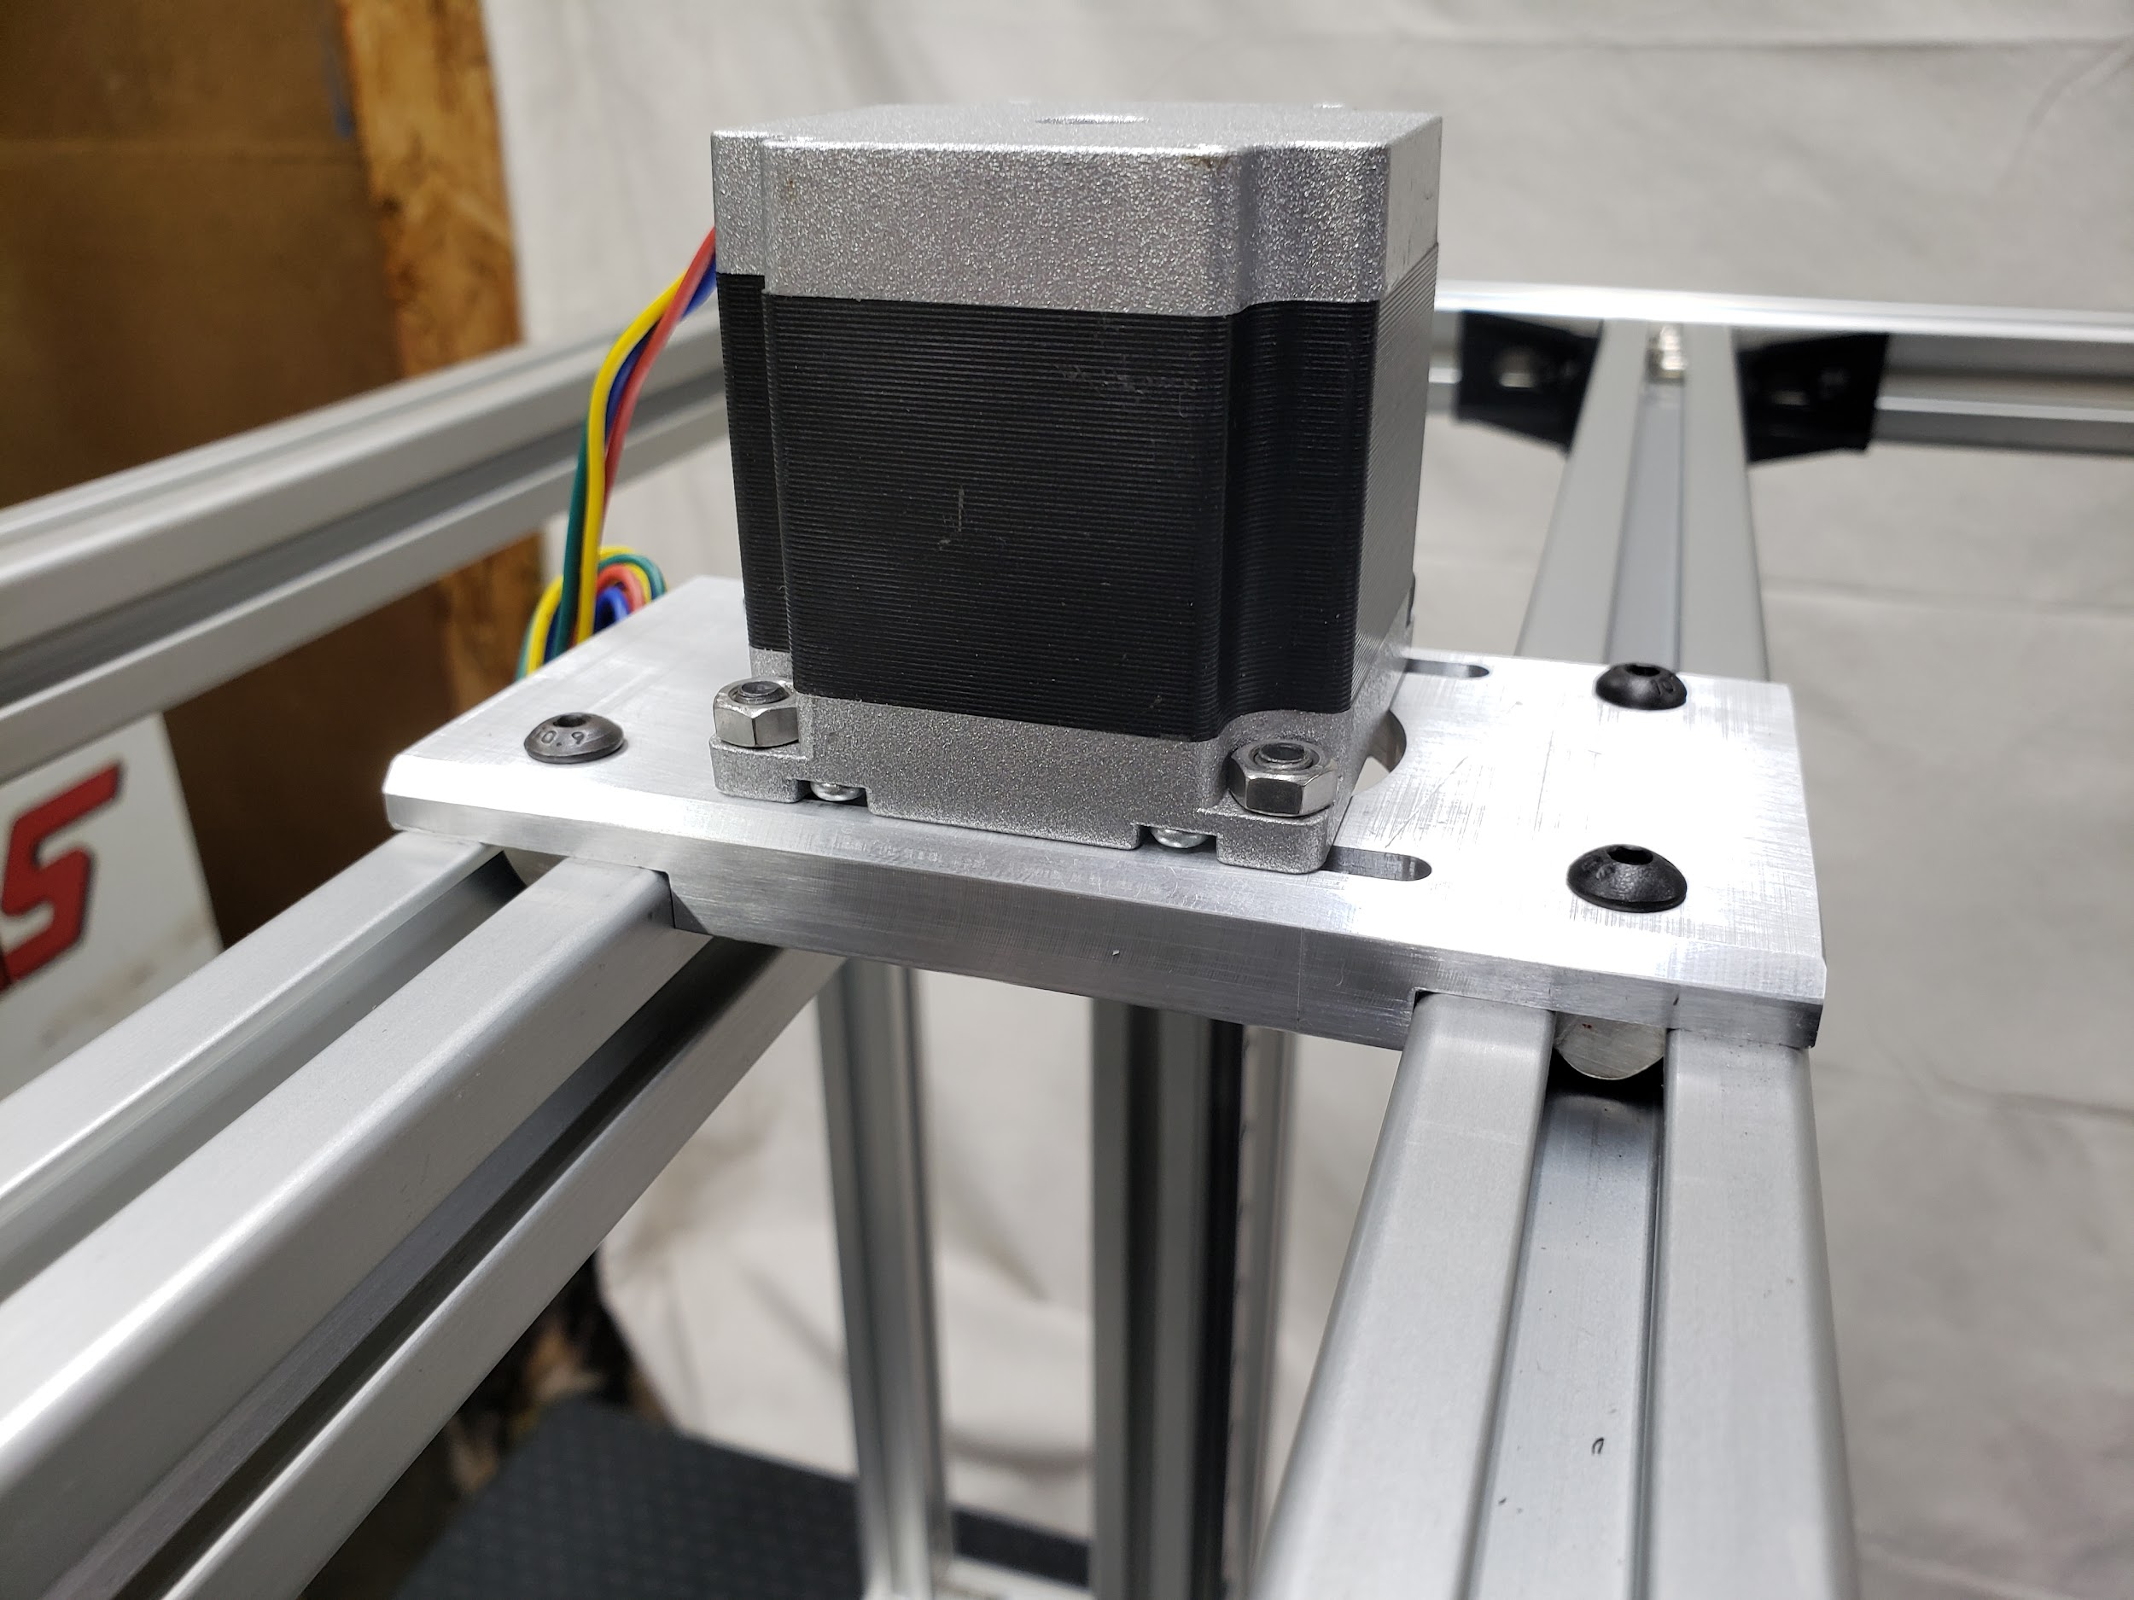

Z-Motor Mount Sizes
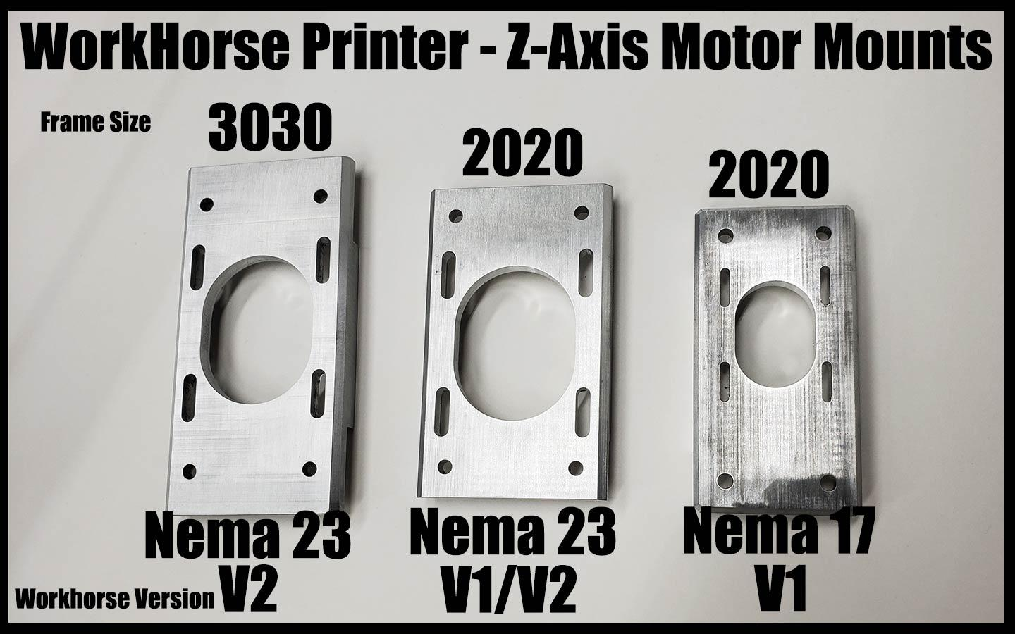

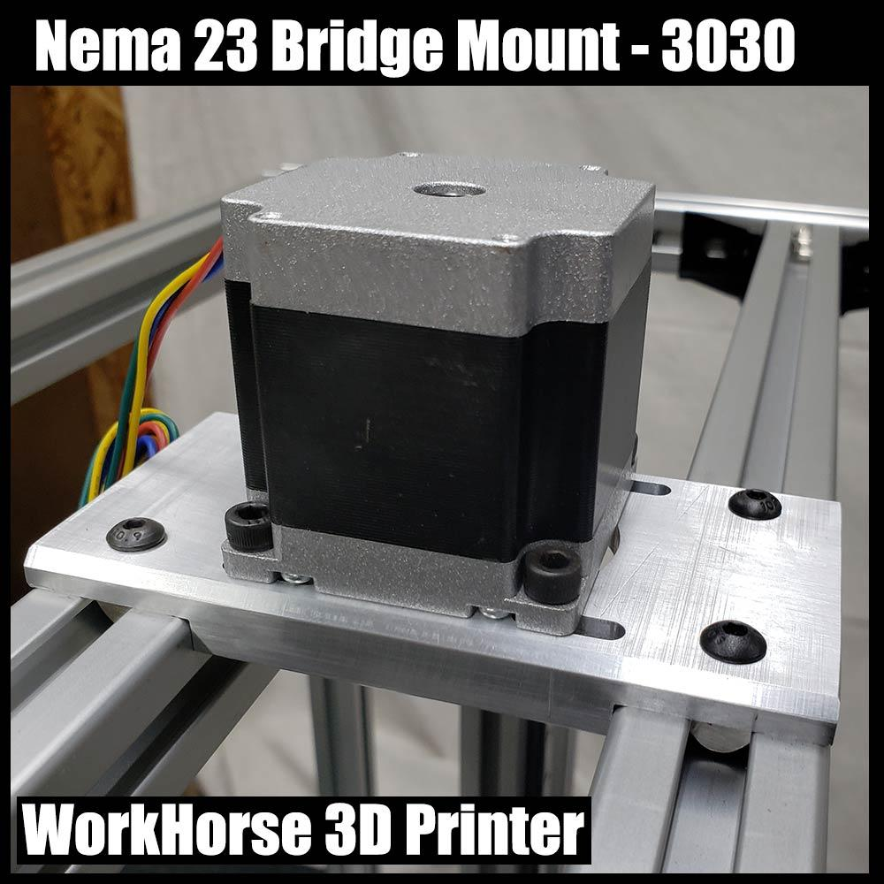

Download

Z-Axis Nema 23 Bridge Mount CAD Files

